Azure Data Factory (ADF) vs Apache Airflow
What is Azure Data Factory?
Azure Data Factory (ADF) is a cloud-based data integration service that allows users to create, schedule, and manage data pipelines for moving and transforming data.
Key Components:
- Pipelines – End-to-end workflows
- Activities – Tasks within pipelines (e.g., Copy Activity)
- Linked Services – Connections to data sources
- Datasets – Data structures
- Integration Runtime – Execution engine
- Triggers – Scheduling pipelines

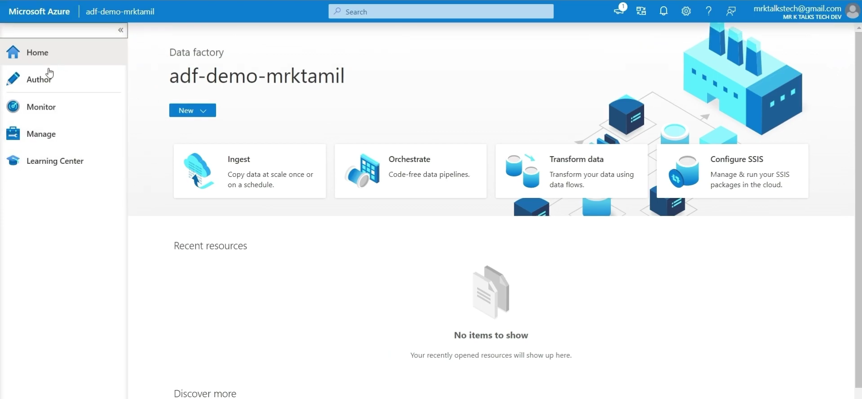
AUTHOR TAB:
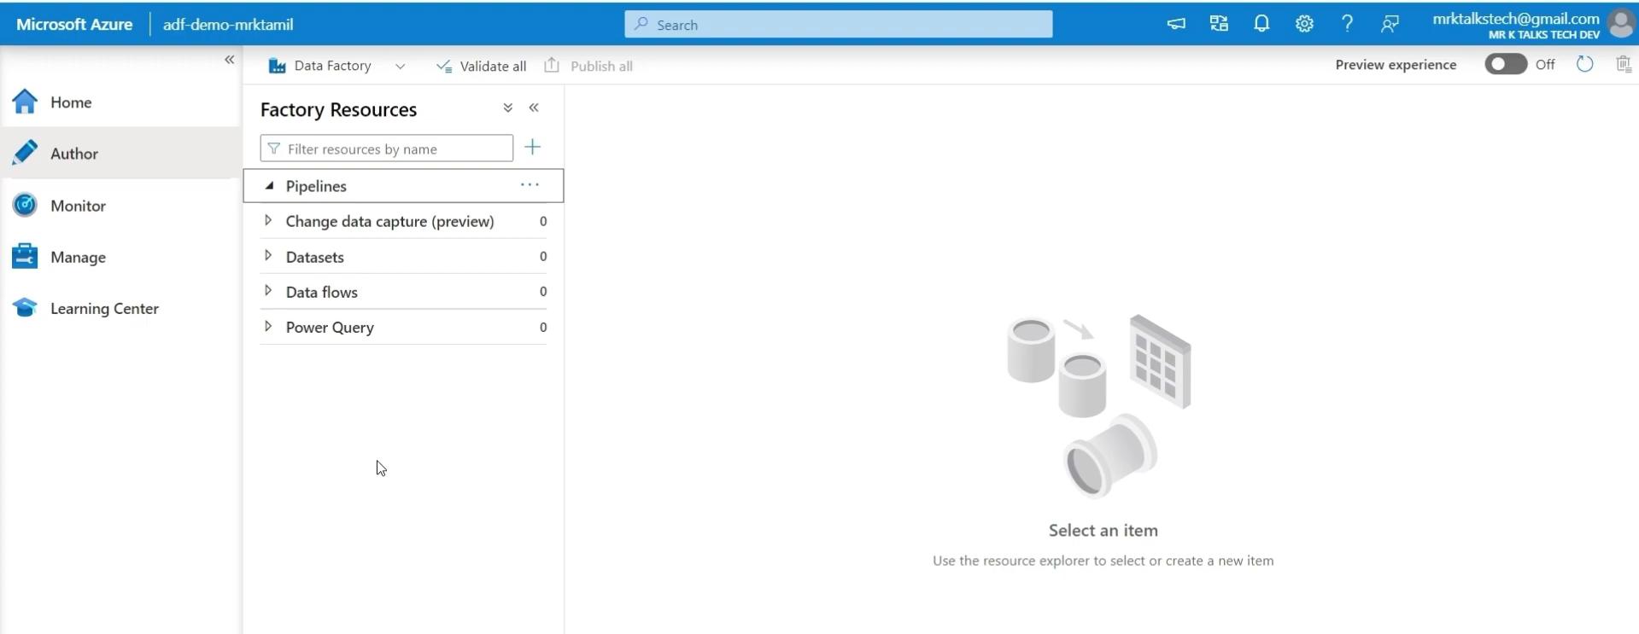
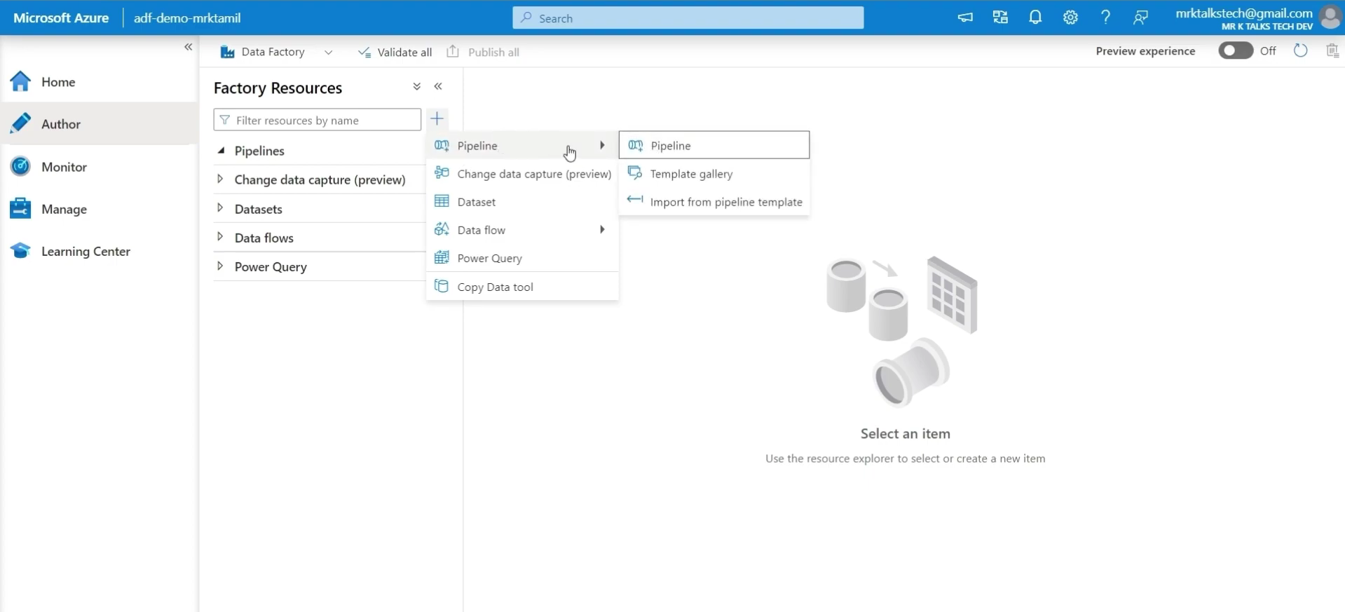
MONITOR TAB:
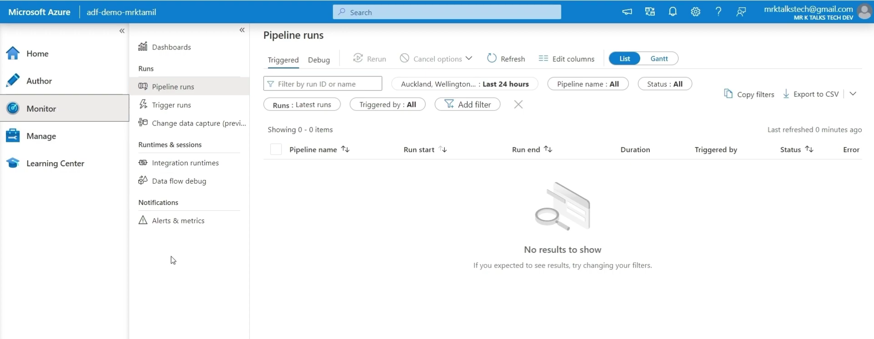
Trigger runs - monitoring
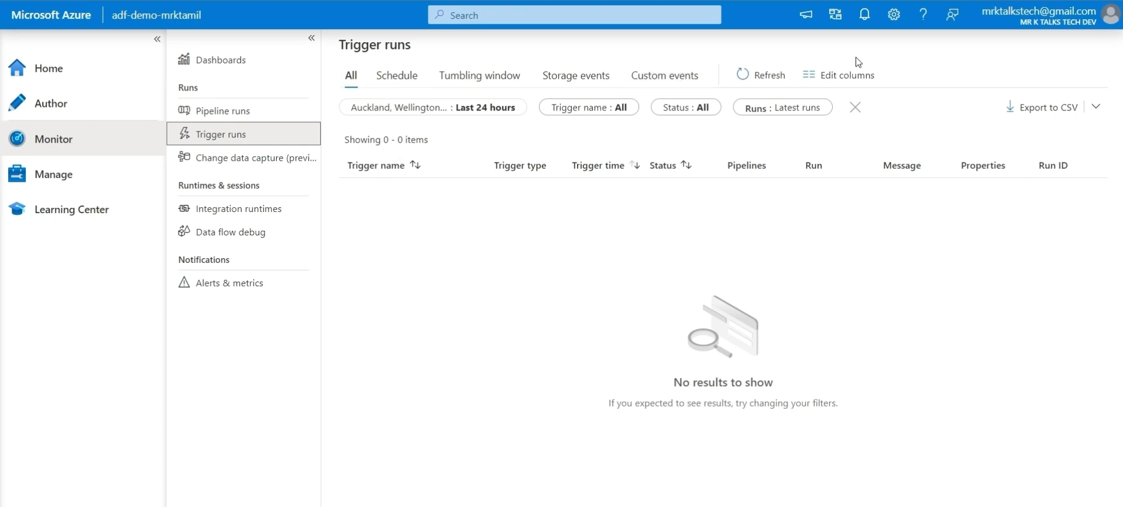
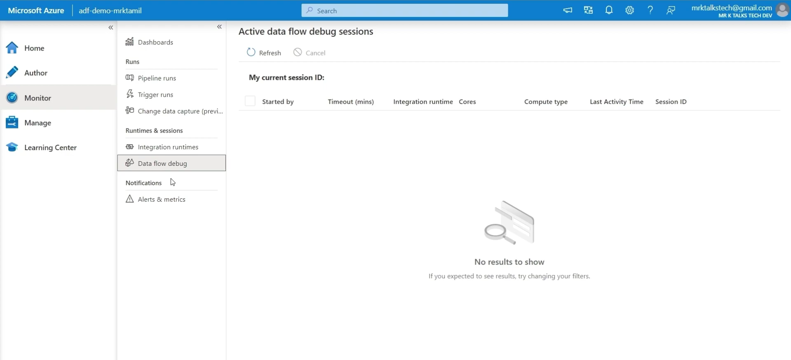

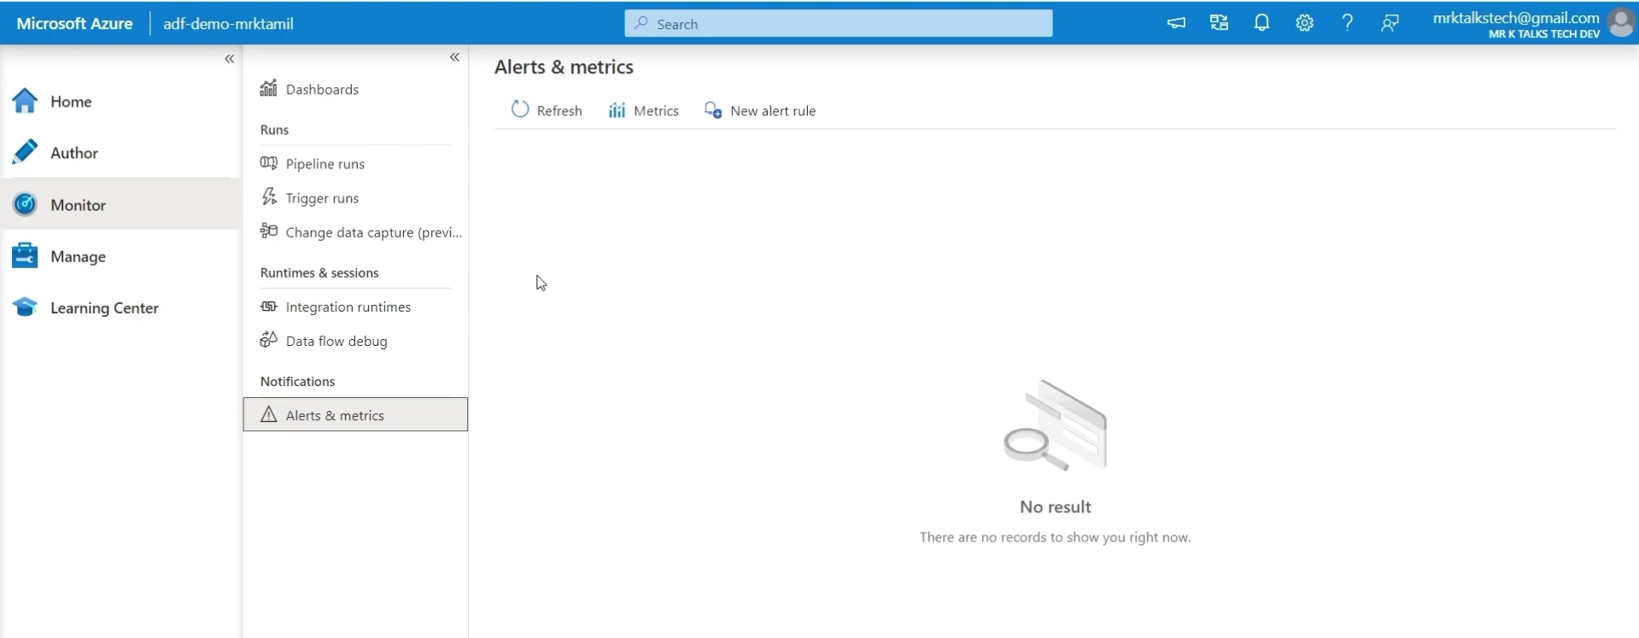

MANAGE TAB:
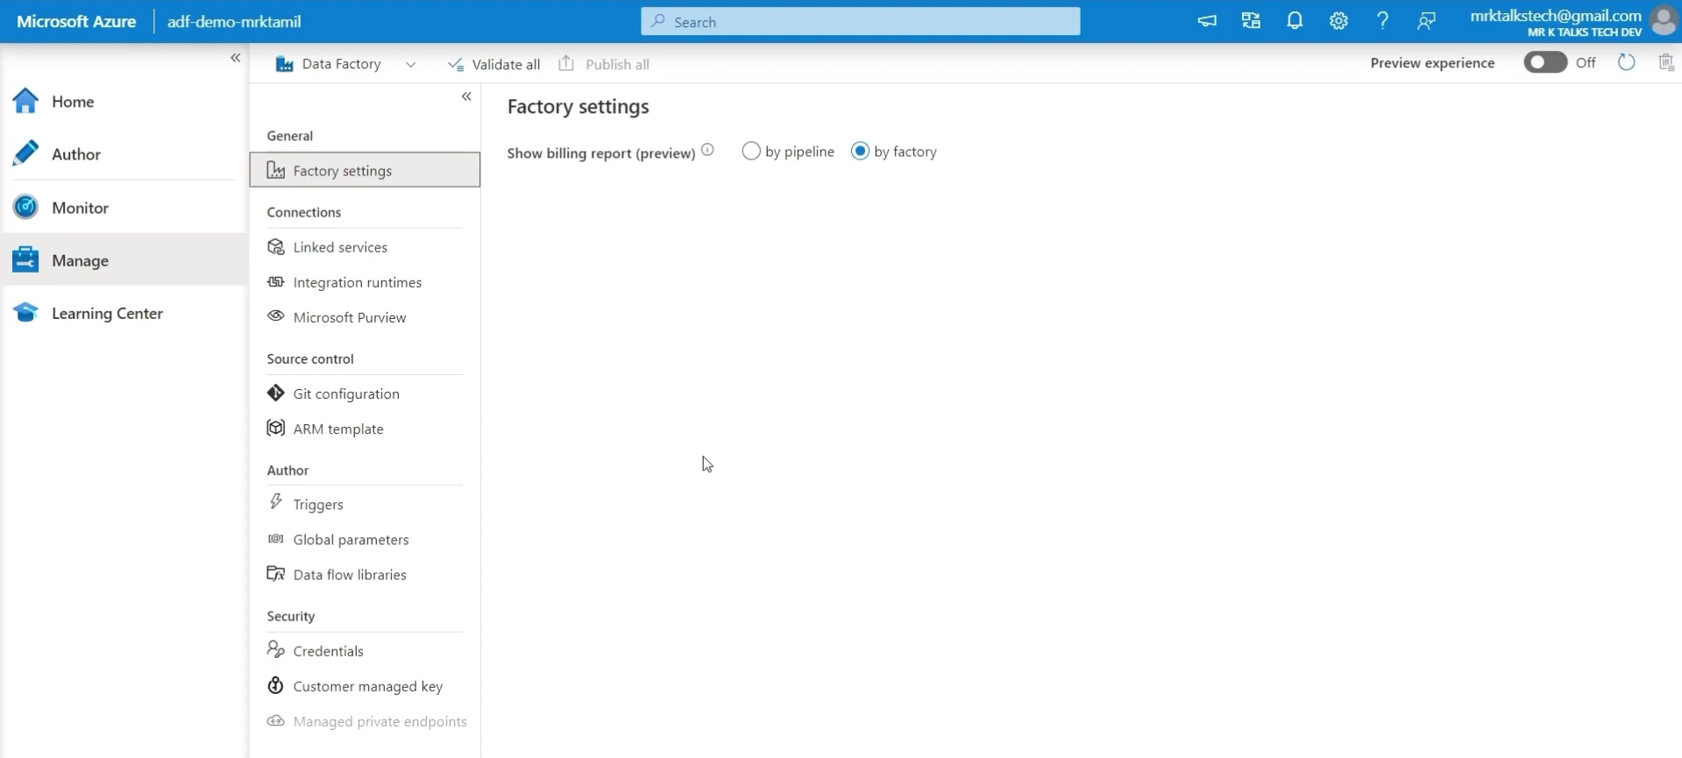
- Linked Services - It must connect to the source/destination
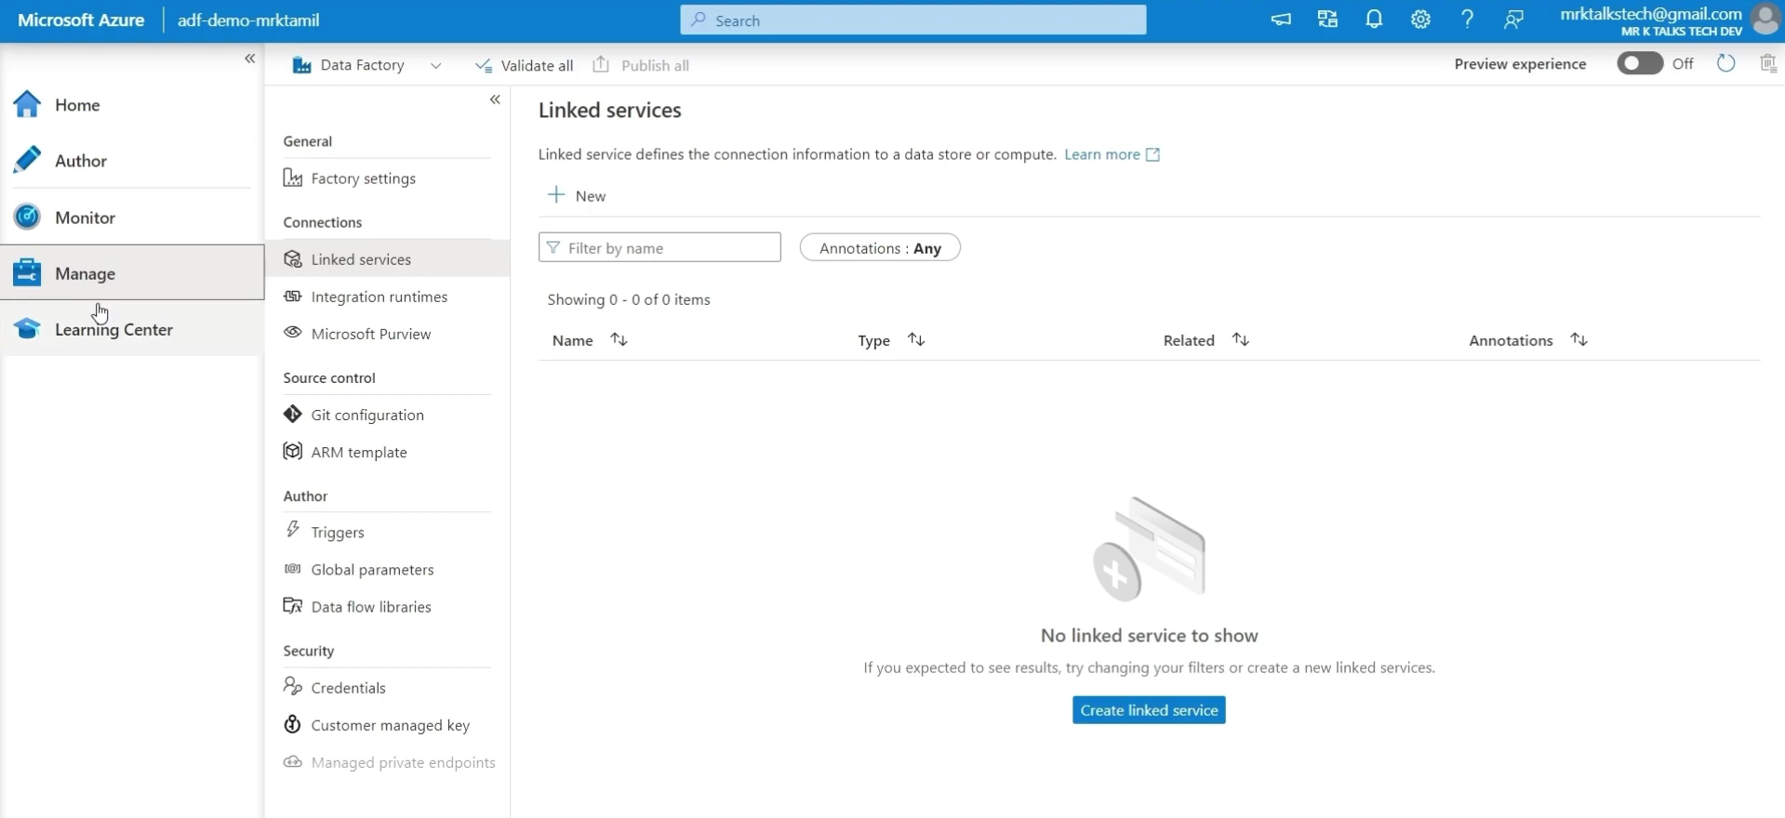
- Integration Runtimes:
Integration Runtime (IR) is the compute infrastructure used by ADF
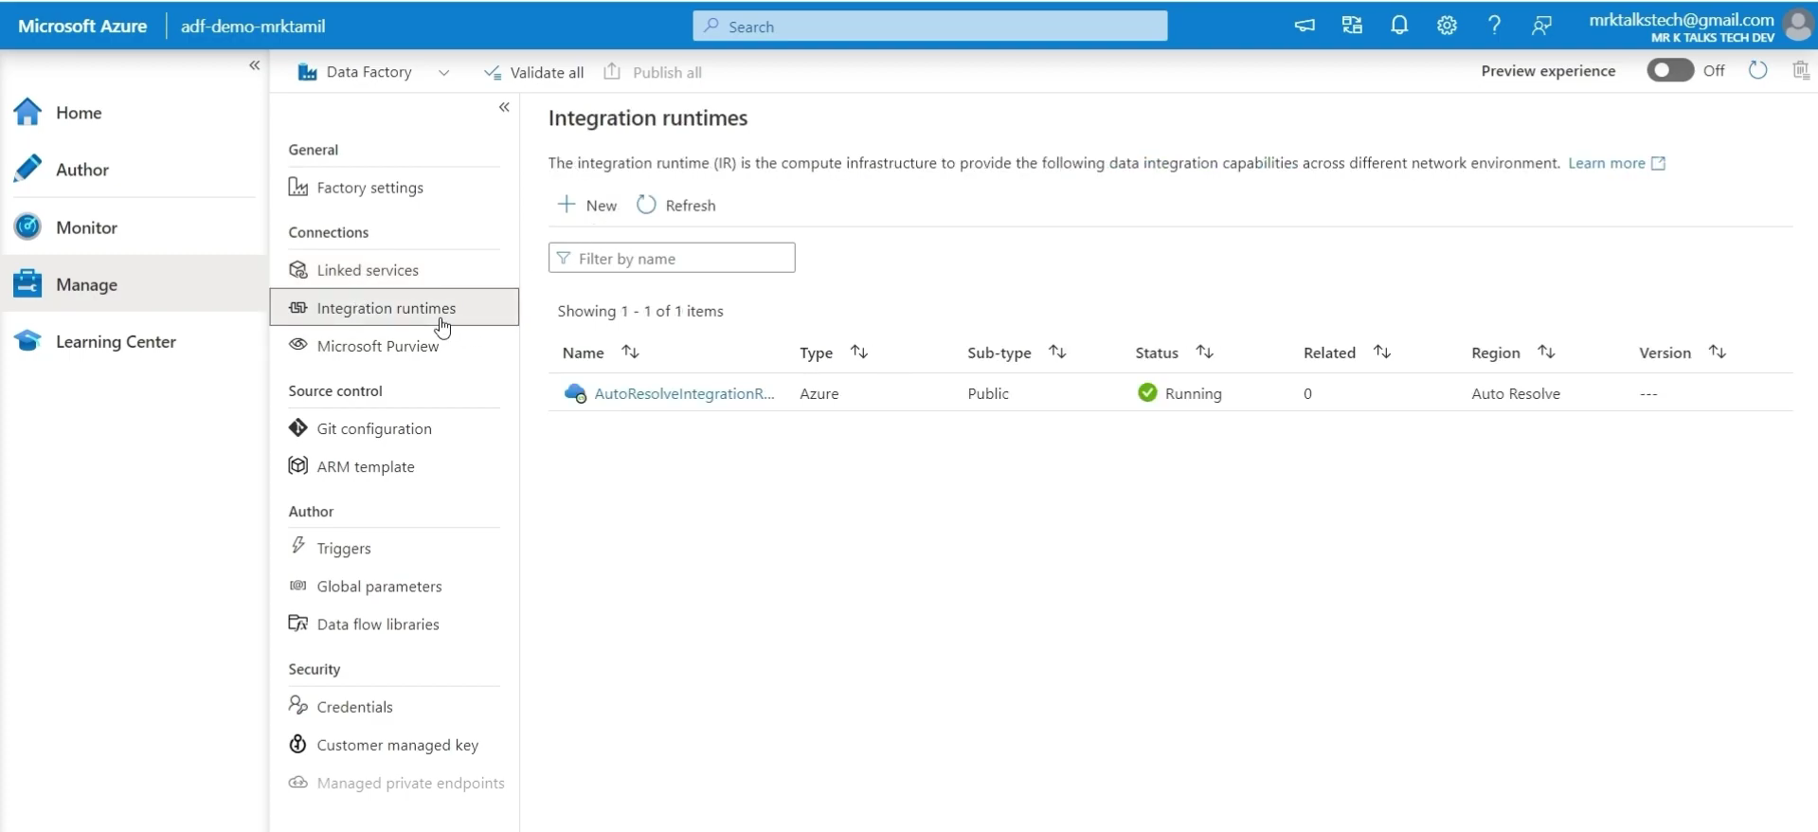
Azure Integration Runtime (Azure IR) - Cloud-to-cloud data movement
Self-hosted Integration Runtime (SHIR) - Local SQL Server → Azure Data Lake
Azure-SSIS Integration Runtime - Old SSIS package → run in Azure
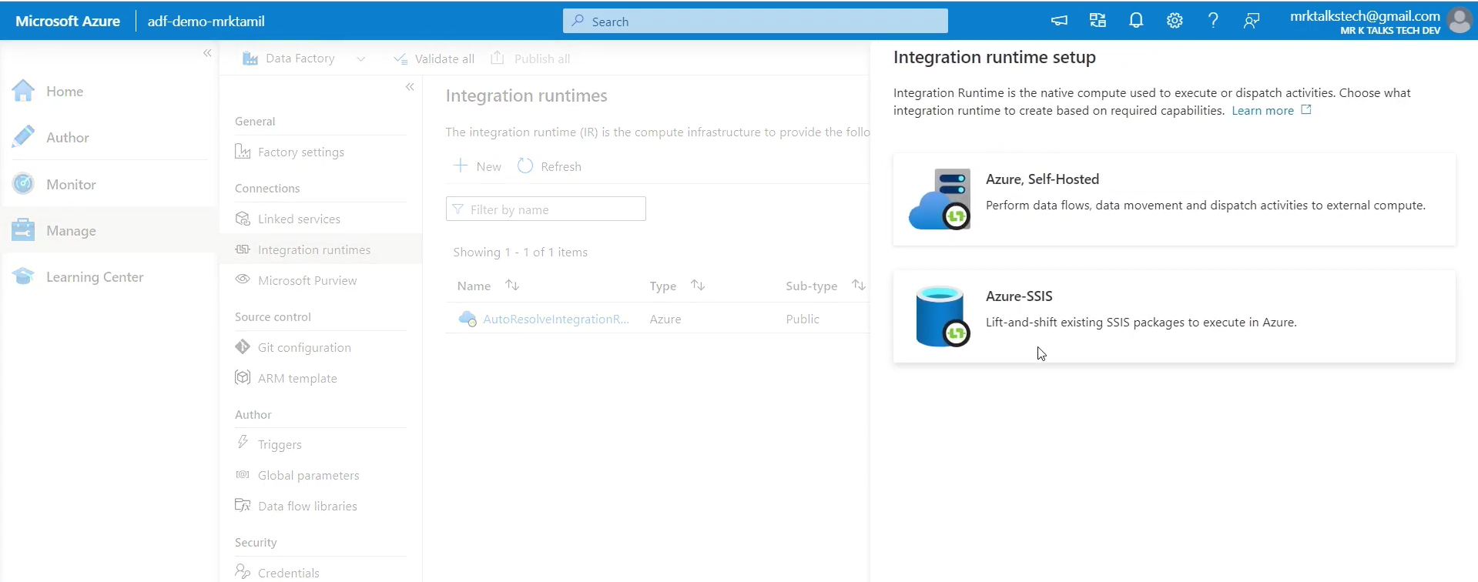
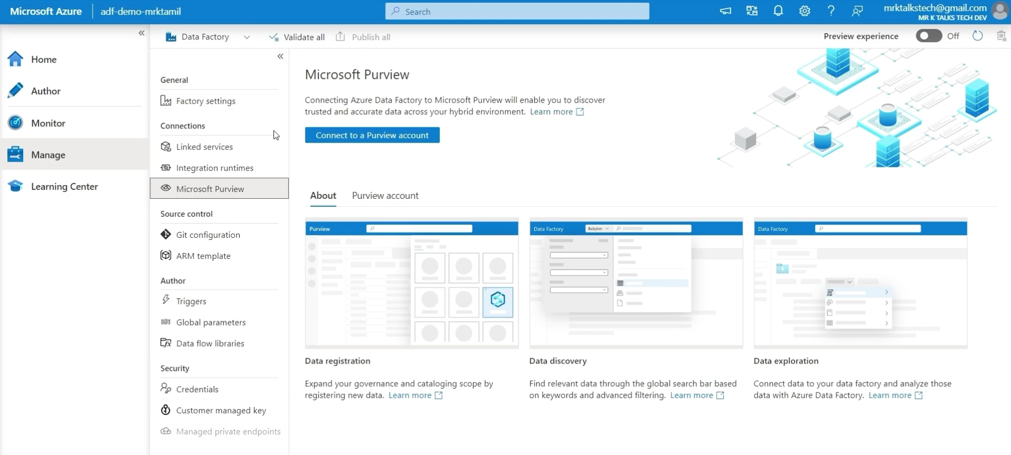

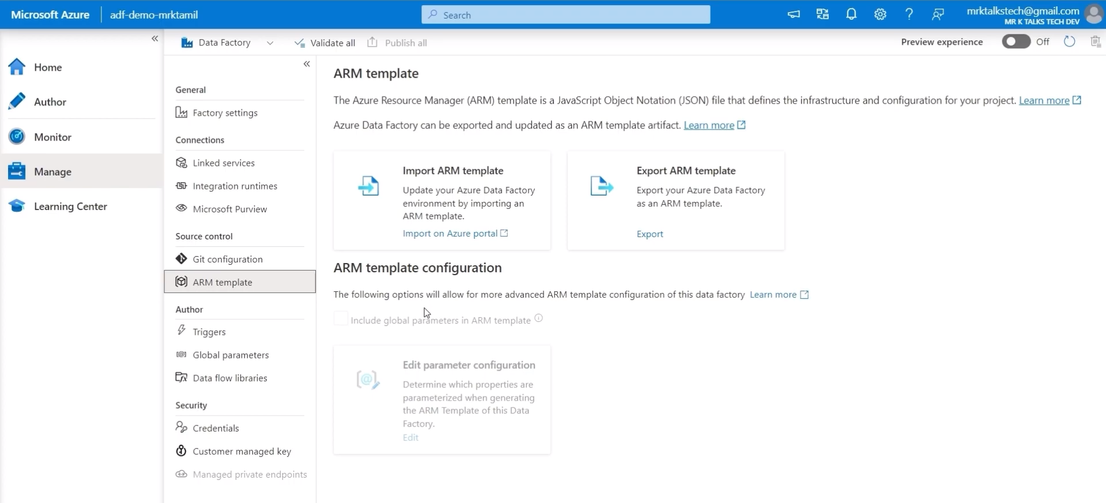
- Triggers (Time-based - daily, hourly. Event-based - file arrives)
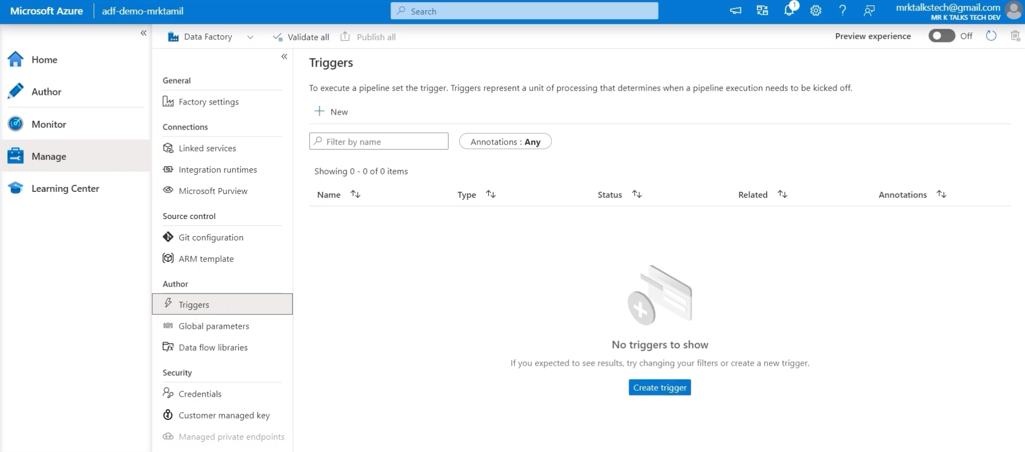
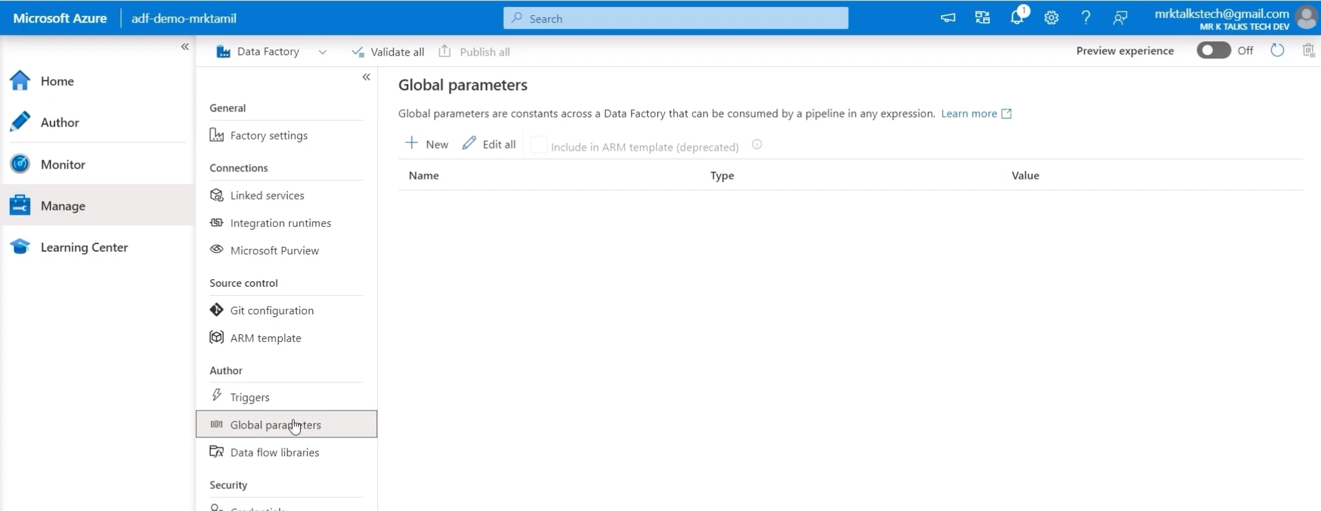
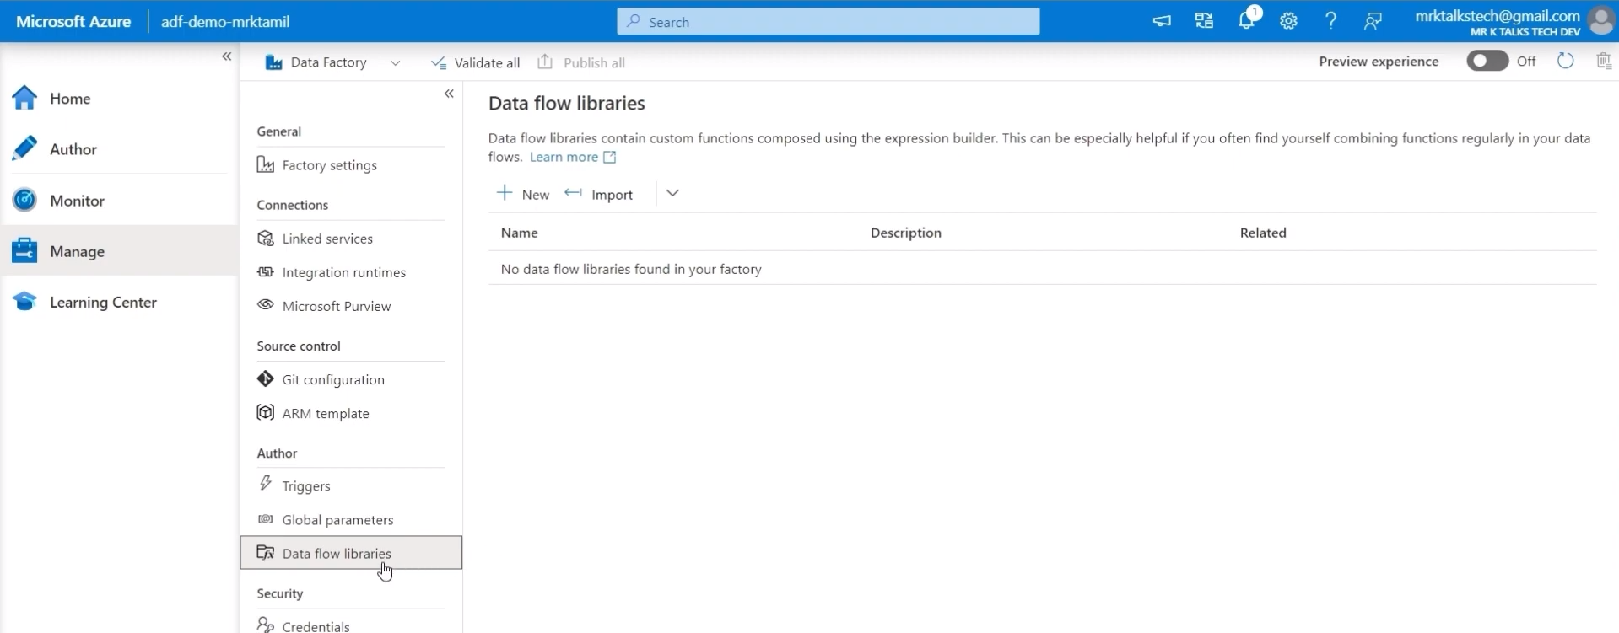

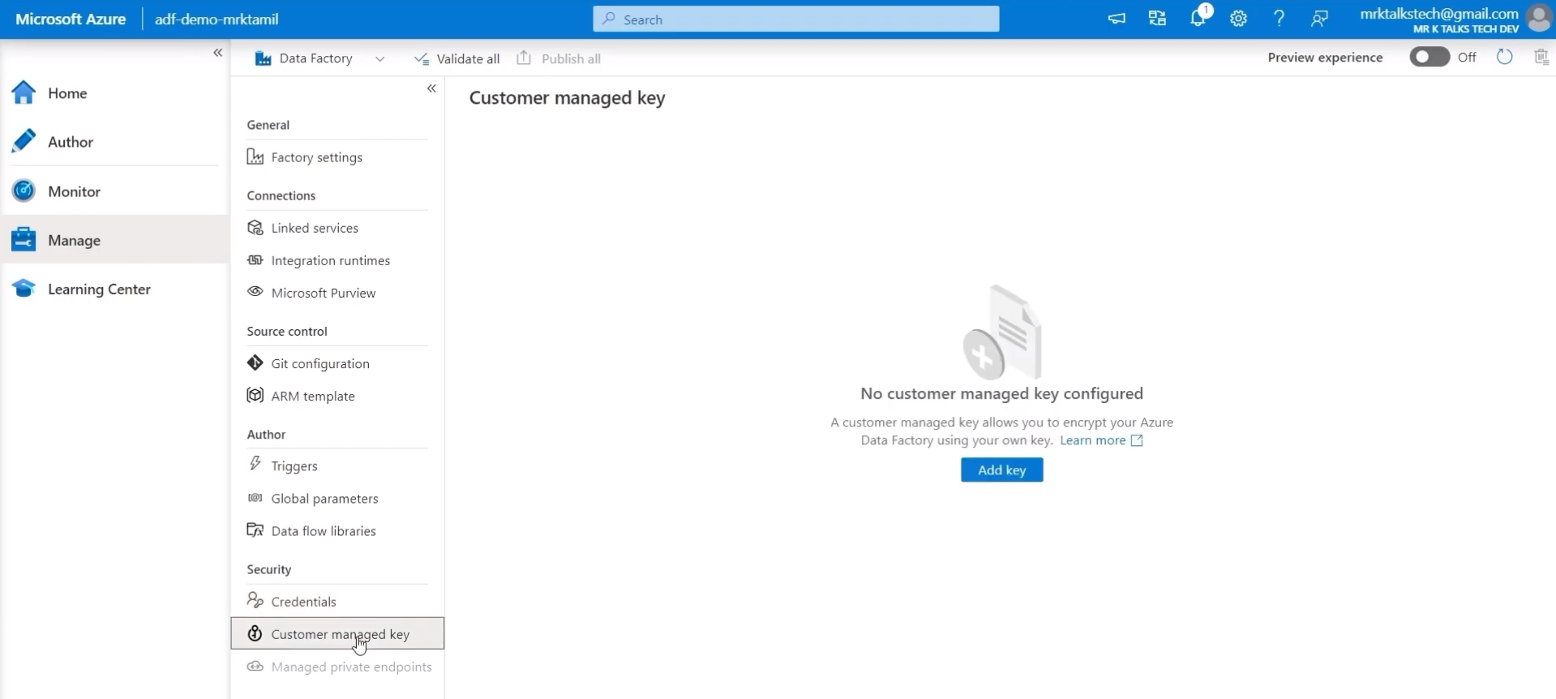
Copy Tool Activity:
We have two container one is source and another one is destination.
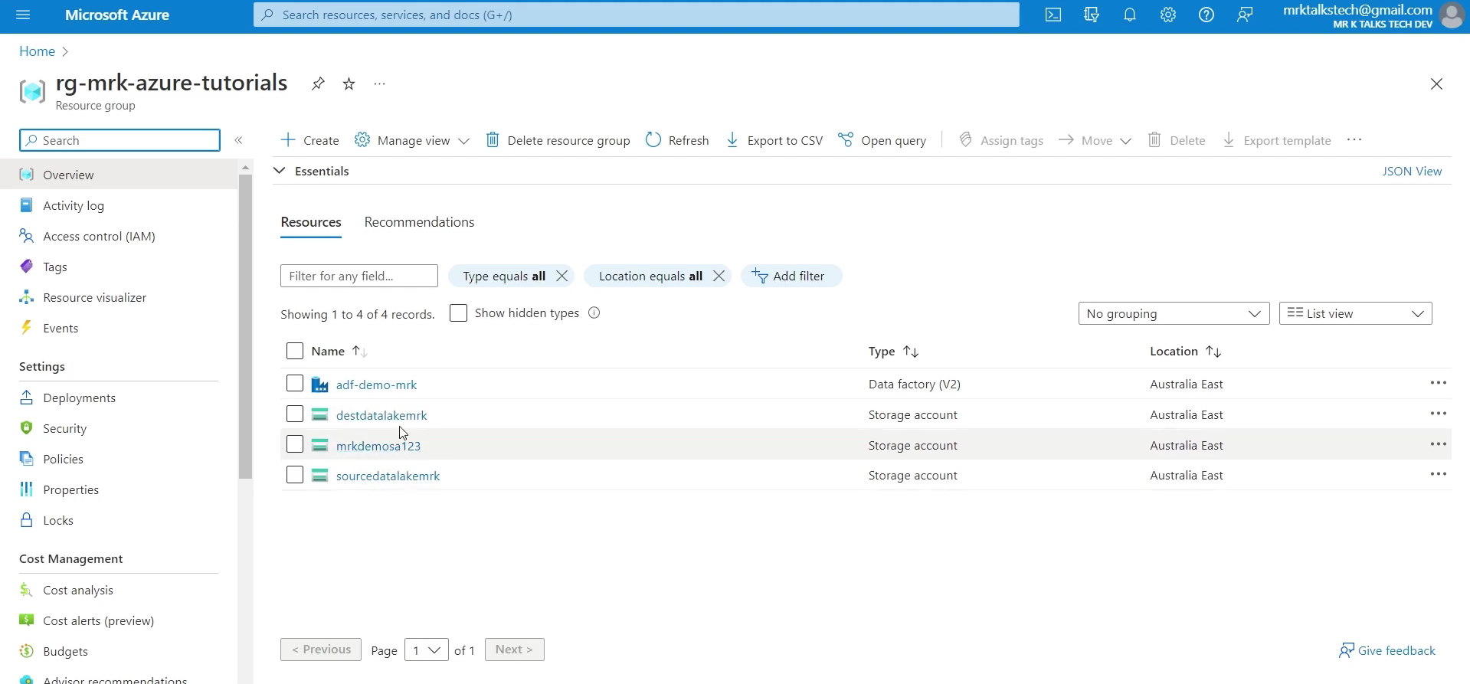
Source have a csv file to use copy tool method to move a csv file source to destination
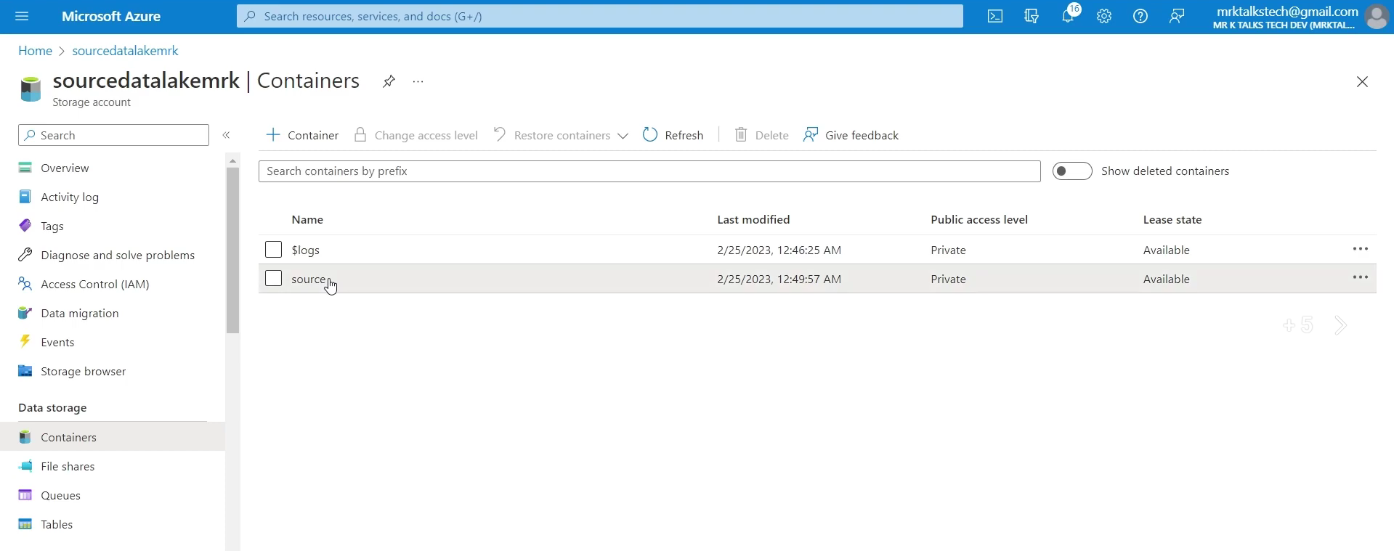
CSV file
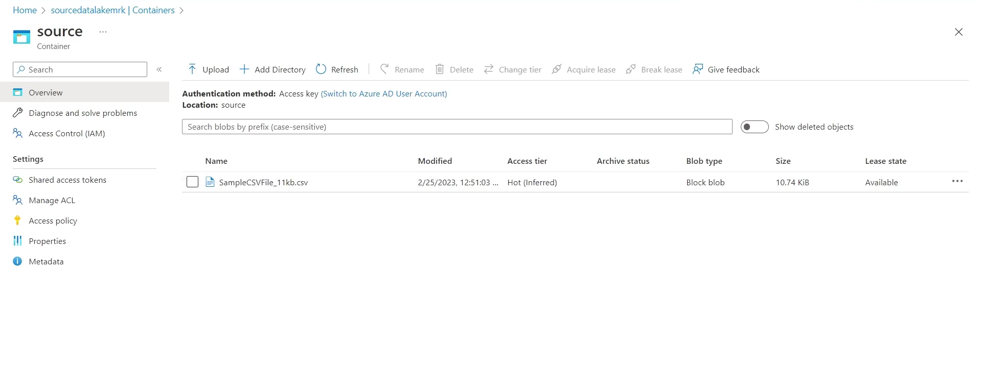
Destination container is blank
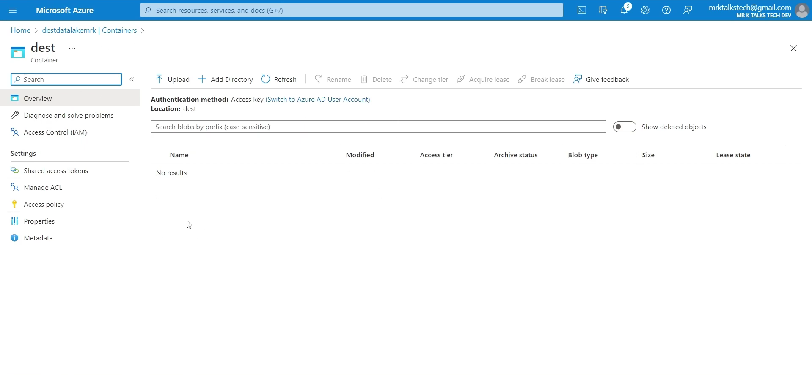
Use copy data tool to create an activity
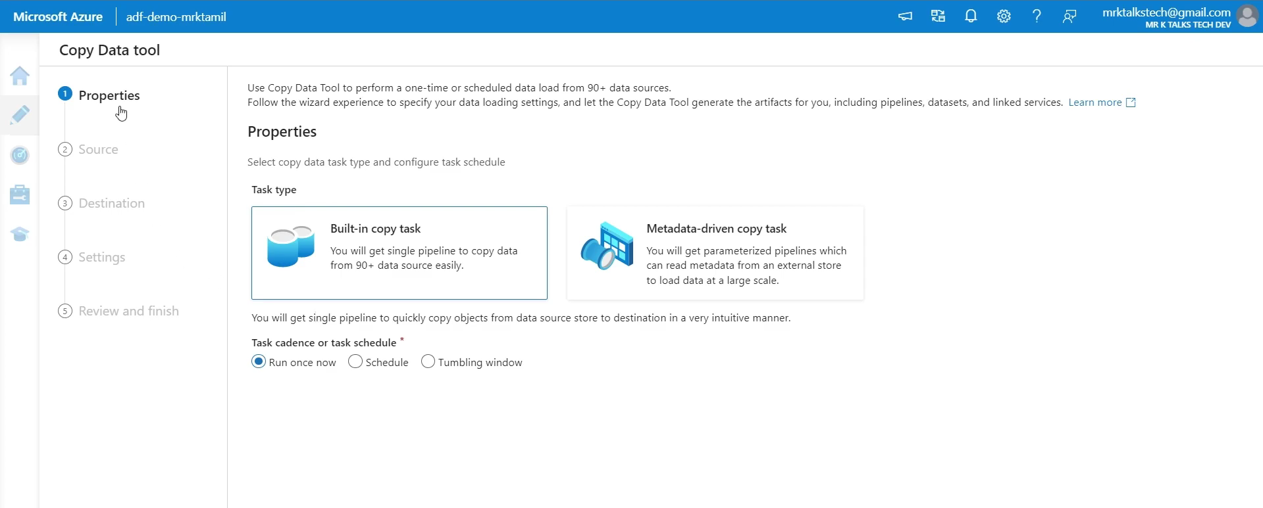
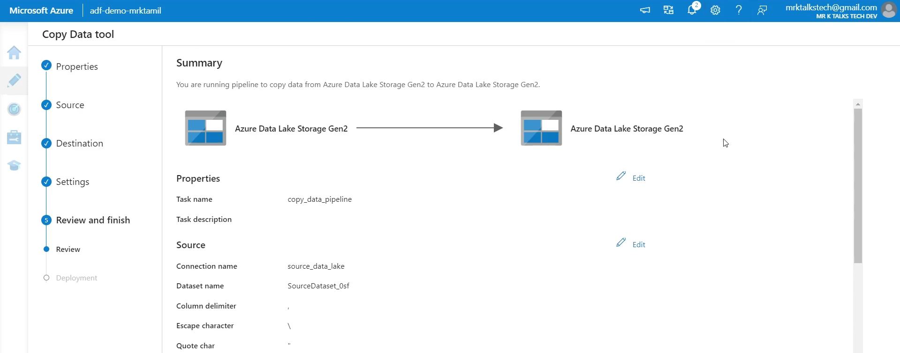
🔹 What is Apache Airflow?
Apache Airflow is an open-source orchestration tool used to programmatically author, schedule, and monitor workflows using Python.
Key Concepts:
- DAG (Directed Acyclic Graph) – Workflow structure
- Operators – Tasks (PythonOperator, BashOperator, EmailOperator)
- Scheduling – Cron-based execution(Helps automate pipelines without manual trigger)
- Task Dependencies – Defines execution order between tasks

ADF vs Apache Airflow
- Visual vs Code-based: Azure Data Factory uses a drag-and-drop visual UI (low-code), while Apache Airflow is fully code-based using Python (DAGs).
- Managed vs Self-hosted: ADF is fully managed by Microsoft (no infrastructure setup), whereas Airflow is typically self-hosted (you manage servers, Docker, or cloud deployment).
- Error Handling & Retry: ADF provides simple built-in retry policies via UI; Airflow offers advanced, customizable retry logic in code.
- Primary Use Case: ADF is best for ETL/ELT pipelines and data integration; Airflow is best for orchestrating complex workflows (data, ML, APIs, etc.).
- Cost Model: Azure Data Factory follows a pay-as-you-go pricing model; Apache Airflow is free but requires infrastructure (VMs, cloud, maintenance cost).
- Version Control: ADF has Git integration but is partly UI-driven; Airflow is fully code-based, making version control (Git) more natural and powerful.

Choose ADF when:
- Project is in Azure
- Need quick ETL pipelines
- Team is less coding-focused
- Building BI dashboards

Choose Airflow when:
- Complex workflows (ETL + ML + APIs)
- Multi-cloud or hybrid systems
- Need custom logic
- Strong Python team

